3 Functions in Business - Crisis Checklist
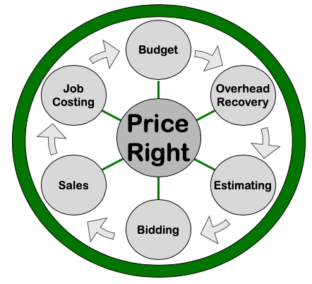
Finance = Price Right
 Review Equipment Rates
 Review Labor Rates
 Review Overhead Expenses

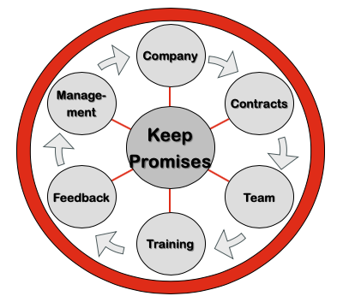
Operations = Keep Promises
 Stagger start times
 Keep same people on same crews each
day
 Reduce size of larger crews
 Provide cleaner and wipes for wiping
down trucks and equipment each day
 Hold team meetings outside or in bigger spaces and
maintain 6 ft distances between everyone

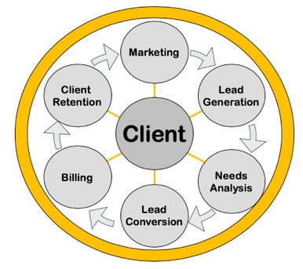
Marketing = Create Clients
 Communicate with Clients – retention
• Call your clients (telequality script)
• USPS, e-mail, text, newsletters, digital
information delivery
• Keep messages brief and effective
• Publish your updated safety practices on
your website, in e-mails and newsletters to your clients
 Minimize physical contact with clients (ex: phone meetings instead of
in person meetings, pausing leaving door hangers after services,
give a ball park price for services over phone based on Zillow or
other database and adjust if needed after initial visit)
 Allow clients to purchase services online
• TAKL, TaskEasy, GreenPal, Mowz, Lawn
Love, etc.

